Key points for students
Creating a chart in Excel
This is a set of data showing the number of students in a class who travelled to school by various means.
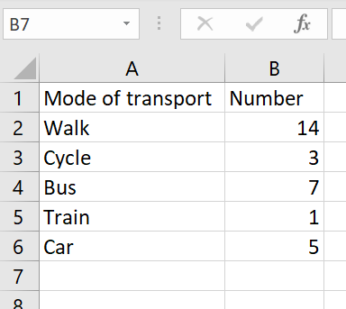
To create a bar chart highlight the data.
Select Insert then a bar chart from the menu bar.
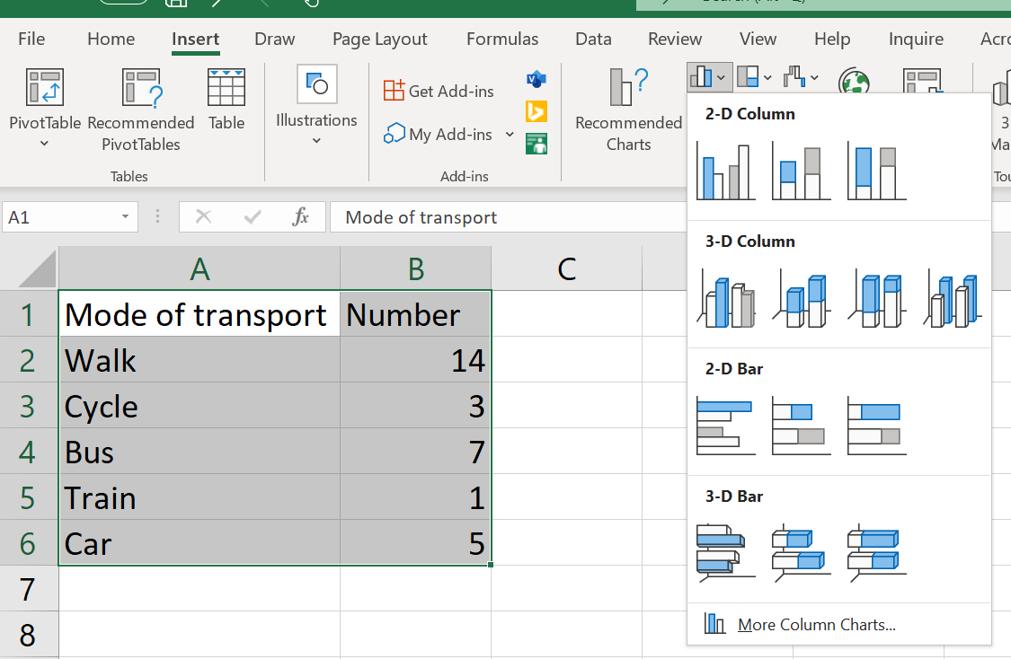
Select the most appropriate type of chart and it will insert a chart onto the sheet:
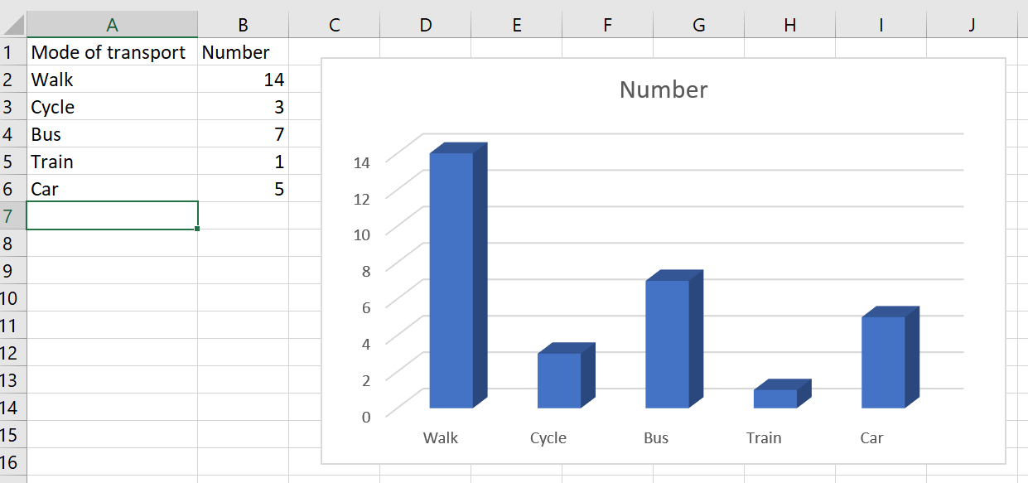
You can edit the text and format by clicking on the elements in the chart.

